TS Home Inspections
Website: http://tshomeinspect.com
Email: tom@tshomeinspect.com
Phone: (815) 343-9123
Minooka IL 60447-8764
Inspector: Thomas Spielman
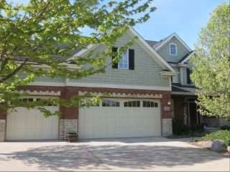

Summary
Client(s): Ryan Brucker
^{Property address:} 25323 W Alison Rd. Plainfield, IL Inspection date: Tuesday, April 25, 2017
This report published on Tuesday, April 25, 2017 10:06:38 PM CDT
This report is the exclusive property of TS Home Inspections and Ryan Brucker. Use of this report by any unauthorized persons is prohibited.
Concerns are shown and sorted according to these types:
 | Safety | Poses a safety hazard
 | Repair/Replace | Recommend repairing or replacing
 | Repair/Maintain | Recommend repair and/or maintenance
 | Minor Defect | Correction likely involves only a minor expense
 | Maintain | Recommend ongoing maintenance
 | Evaluate | Recommend evaluation by a specialist
 | Monitor | Recommend monitoring in the future
 | Serviceable | Item or component is in servicable condition
 | Comment | For your information

TS Home Inspections SUMMARY
- The soil or grading sloped down towards building perimeters in front and back by sump pump drain. This can result in water accumulating around building
Grounds

1

foundations or underneath buildings. It is a conducive condition for wood-destroying organisms. Recommend grading soil so it slopes down and away from buildings with a slope of at least 1 inch per horizontal foot for at least 6 feet out from buildings.
- Evidence of prior water intrusion was found in one area of the basement. On wall with crack near water heater and furnace. Accumulated water is a conducive
Exterior and Foundation

6

-
One minor crack (1/8 inch or less) was found in the foundation on garage side. This didn't appear to be a structural concern, but recommend sealing to prevent water
infiltration and monitor them in the future. Numerous products exist to seal such cracks including hydraulic cement, non
-
shrinking grout, resilient caulks and epoxy
sealants.

7

-
Radon Vent too low. Recommend having a qualified technician install correctly. (It should extent above roof line).

Basement

9

condition for wood-destroying organisms and should not be present in the basement. Recommend reviewing any disclosure statements available and ask the property owner about past accumulation of water in the basement. The basement should be monitored in the future for accumulated water, especially after heavy and/or prolonged periods of rain. If water is found to accumulate, then recommend that a qualified contractor who specializes in drainage issues evaluate and repair as necessary. Typical repairs for preventing water from accumulating in basements include:
- Repairing, installing or improving rain run-off systems (gutters, downspouts and extensions or drain lines) ● Improving perimeter grading
- Repairing, installing or improving underground footing and/or curtain drains
Ideally, water should not enter basements, but if water must be controlled after it enters the basement, then typical repairs include installing a sump pump.
Roof

11

-
Extensions such as splash blocks or drain pipes for one or more downspouts were missing. Water can accumulate around the building foundation or inside crawl
spaces or basements as a result. Recommend that a qualified person install, replace or repair extensions as necessary so rainwater drains away from the structure.

Attic and Roof Structure

13

-
Both attic access hatches or doors were not insulated. Weatherstripping was also missing. Recommend installing weatherstripping and insulation per current
standards at hatches or doors for better energy efficiency. For more information, visit:

http://www.reporthost.com/?ATTACC
Electric

14

-
Carbon monoxide alarm were missing in basement. This is a potential safety hazard. Some states and/or municipalities require CO alarms to be installed in the
vicinity of each sleeping area, on each level and in accordance with the manufacturer's recommendations. Recommend installing additional carbon monoxide alarms per these standards. For more information, visit:
- I was unable to determine the last service date on both furnaces and A/C. Ask the property owner when it was last serviced. If unable to determine the last
M
http://www.reporthost.com/?COALR

15

-
Some breakers in main service panel appear to be loose. I noticed when removing the cover of the panel, lights were flashing on and off. Recommend a qualified
electrician evaluate and a make necessary corrections.

16

-
Main panel not fully secured to wall. I noticed some movement of the panel when removing the cover. Recommend a qualified electrician evaluate and make
necessary corrections.

Heating, Ventilation and Air Condition (HVAC)

18

service date, or if this system was serviced more than 1 year ago, recommend that a qualified HVAC contractor inspect, clean, and service this system, and make repairs if necessary. For safety reasons, and because this system is fueled by gas, this servicing should be performed annually in the future. Any needed repairs noted in this report should be brought to the attention of the HVAC contractor when it's serviced. For more information visit: http://www.reporthost.com/?ANFURINSP

^{Ryan Brucker}Tuesday, April 25, 2017 25323 W Alison Rd. Plainfield, IL
SUMMARY

Fireplaces, Stoves, Chimneys and Flues
20 - Recommend that the client review all available documentation for gas-fired fireplaces. Depending on how they are operated (for routine heating versus ambiance), such appliances may need servicing annually or every few years. Consult with the property owner and/or a qualified specialist to determine if service is needed now.
Interior, Doors and Windows

22

-
Crank handles at kitchen, livingroom and master bedroom windows were loose and/or broken. Recommend that a qualified person replace handles or make repairs
as necessary.

23

-
Wood flooring in some areas was
worn. Recommend that a qualified contractor refinish wood flooring as necessary.

TS Home Inspections
Website: http://tshomeinspect.com
Email: tom@tshomeinspect.com
Phone: (815) 343-9123
Minooka IL 60447-8764
Inspector: Thomas Spielman

Property Inspection of 25323 W Alison Rd. Plainfield, IL
Client(s): Ryan Brucker
^{Property address:} 25323 W Alison Rd. Plainfield, IL Inspection date: Tuesday, April 25, 2017
This report published on Tuesday, April 25, 2017 10:06:38 PM CDT
This report is the exclusive property of TS Home Inspections and Ryan Brucker. Use of this report by any unauthorized persons is prohibited.

How to Read this Report
This report is organized by the property's functional areas. Within each functional area, descriptive information is listed first and is shown in bold type. Items of concern follow descriptive information. Concerns are shown and sorted according to these types:
 | Safety | Poses a safety hazard
 | Repair/Replace | Recommend repairing or replacing
 | Repair/Maintain | Recommend repair and/or maintenance
 | Minor Defect | Correction likely involves only a minor expense
 | Maintain | Recommend ongoing maintenance
 | Evaluate | Recommend evaluation by a specialist
 | Monitor | Recommend monitoring in the future
 | Serviceable | Item or component is in servicable condition
 | Comment | For your information

General Information
Report number: 142517a
Time started: 9am
Time finished: 11:50am
Present during inspection: Client, Realtor
Client present for discussion at end of inspection: Yes
Weather conditions during inspection: Dry (no rain), Sunny
Temperature during inspection: Cool
Payment method: Check
Type of building: Single family
Buildings inspected: One house
Number of residential units inspected: 1
Age of main building: 11yrs
Occupied: Yes

Grounds
Limitations: Unless specifically included in the inspection, the following items and any related equipment, controls, electric systems and/or plumbing systems are excluded from this inspection: detached buildings or structures; fences and gates; retaining walls; underground drainage systems, catch basins or concealed sump pumps; swimming pools and related safety equipment, spas, hot tubs or saunas; whether deck, balcony and/or stair membranes are watertight; trees, landscaping, properties of soil, soil stability, erosion and erosion control; ponds, water features, irrigation or yard sprinkler systems; sport courts, playground, recreation or leisure equipment; areas below the exterior structures with less than 3 feet of vertical clearance; invisible fencing; sea walls, docks and boathouses; retractable awnings. Any comments made regarding these items are as a courtesy only. Site profile: Level, Minor slope, away in back
Condition of driveway: Appeared serviceable
Driveway material: Poured in place concrete
Condition of sidewalks and/or patios: Appeared serviceable
Sidewalk material: Poured in place concrete
Condition of deck, patio and/or porch covers: Appeared serviceable
Deck, patio, porch cover material and type: Covered (Refer to Roof section)
Condition of decks, porches and/or balconies: Appeared serviceable
Deck, porch and/or balcony material: Wood, Concrete
Condition of stairs, handrails and guardrails: Appeared serviceable
Exterior stair material: Wood
1) The soil or grading sloped down towards building perimeters in front and back by sump pump drain. This can result in water accumulating around building foundations or underneath buildings. It is a conducive condition for wood-destroying organisms. Recommend grading soil so it slopes down and away from buildings with a slope of at least 1 inch per horizontal foot for at least 6 feet out from buildings.
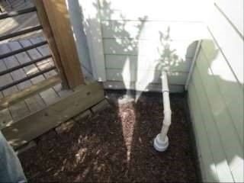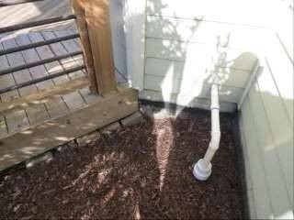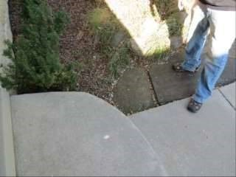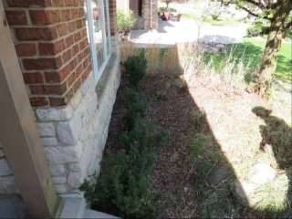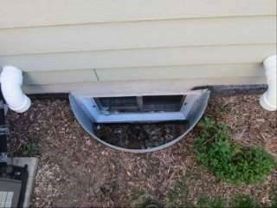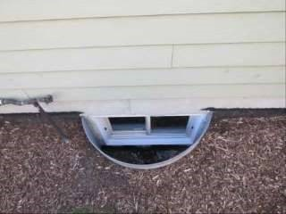 Wooden deck or porch surfaces and/or railings were overdue for normal maintenance. Recommend that a qualified person clean and preserve as necessary. Where decks have been coated with a finish such as opaque stains or paint, it may be too difficult to strip the finish and apply anything but paint or opaque stain. Where transparent stain or penetrating oil has been applied in the past, recommend that a penetrating oil be used. For more information, visit:
2)

No window well covers. Recommend installing to prevent blockage of drains and keeping vermin out.

3)

Photo 1
-
1

Photo 1
-
2

Photo 1
-
3

Photo 1
-
4

Photo 2
-
1

Photo 2
-
2

http://www.reporthost.com/?PENOIL http://www.reporthost.com/?DKMAIN
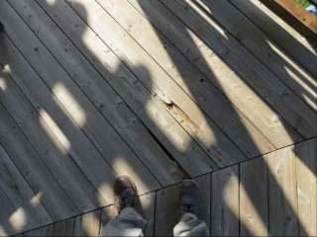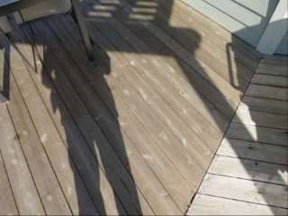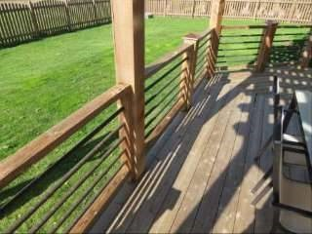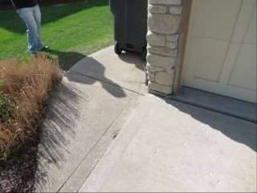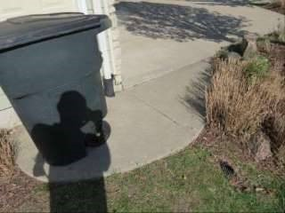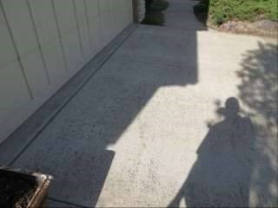

4)
Minor heaving toward building was found in sidewalk by garage. This may cause excess water to collect in this area.

5)
Minor cracking was found in the driveway, but no trip hazards were found. The client may wish to have repairs made for cosmetic reasons.

Photo 3
-
1

Photo 3
-
2

Photo 3
-
3

Photo 4
-
1

Photo 4
-
2

Photo 5
-
1

Exterior and Foundation
Limitations: The inspector performs a visual inspection of accessible components or systems at the exterior. Items excluded from this inspection include below-grade foundation walls and footings; foundations, exterior surfaces or components obscured by vegetation, stored items or debris; wall structures obscured by coverings such as siding or trim. Some items such as siding, trim, soffits, vents and windows are often high off the ground, and may be viewed using binoculars from the ground or from a ladder. This may limit a full evaluation. Regarding foundations, some amount of cracking is normal in concrete slabs and foundation walls due to shrinkage and drying. Note that the inspector does not determine the adequacy of seismic reinforcement.
Wall inspection method: Viewed from ground
Condition of wall exterior covering: Appeared serviceable
Apparent wall structure: Wood frame
Wall covering: Cement fiber, Brick veneer
Condition of foundation and footings: Appeared serviceable
Apparent foundation type: Unfinished basement
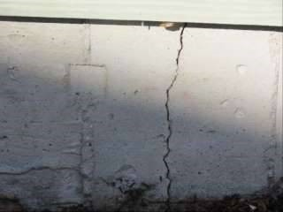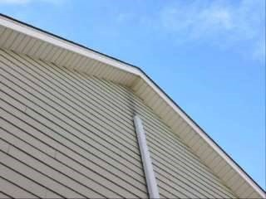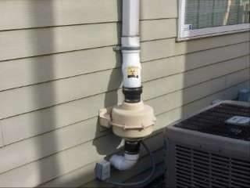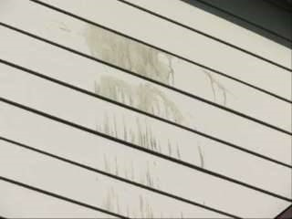
Foundation/stem wall material:
Poured in place concrete

Footing material (under foundation stem wall):
Poured in place concrete

6)
One minor crack (1/8 inch or less) was found in the foundation on garage side. This didn't appear to be a structural concern, but recommend sealing to prevent water
infiltration and monitor them in the future. Numerous products exist to seal such cracks including hydraulic cement, non
-
shrinking grout, resilient caulks and epoxy
sealants.

7)

Radon Vent too low. Recommend having a qualified technician install correctly. (It should extent above roof line).

8)
Staining on siding. Recommend having cleaned.

Photo 6
-
1

Photo 7
-
1

Photo 7
-
2

Photo 8
-
1

Basement
Limitations: Structural components such as joists and beams, and other components such as piping, wiring and/or ducting that are obscured by under-floor insulation are also excluded from this inspection. Note that the inspector does not determine if support posts, columns, beams, joists, studs, trusses, etc. are of adequate size, spanning or spacing.

The inspector does not guarantee or warrant that water will not accumulate in the basement in the future. Access to the basement during all seasons and during prolonged periods of all types of weather conditions (e.g. heavy rain, melting snow) would be needed to do so. The inspector does not determine the adequacy of basement floor or stairwell drains, or determine if such drains are clear or clogged.

Note that all basement areas should be checked periodically for water intrusion, plumbing leaks and pest activity.
Condition of floor substructure above: Appeared serviceable
Pier or support post material: Steel
Beam material: Steel
Floor structure above: Solid wood joists
9) Evidence of prior water intrusion was found in one area of the basement. On wall with crack near water heater and furnace. Accumulated water is a conducive condition for wood-destroying organisms and should not be present in the basement. Recommend reviewing any disclosure statements available and ask the property owner about past accumulation of water in the basement. The basement should be monitored in the future for accumulated water, especially after heavy and/or prolonged periods of rain. If water is found to accumulate, then recommend that a qualified contractor who specializes in drainage issues evaluate and repair as necessary. Typical repairs for preventing water from accumulating in basements include:
- Repairing, installing or improving rain run-off systems (gutters, downspouts and extensions or drain lines) ● Improving perimeter grading
- Repairing, installing or improving underground footing and/or curtain drains
Ideally, water should not enter basements, but if water must be controlled after it enters the basement, then typical repairs include installing a sump pump.
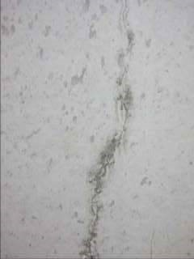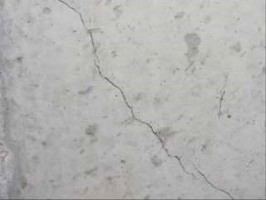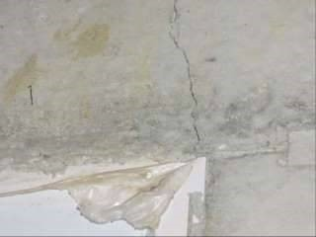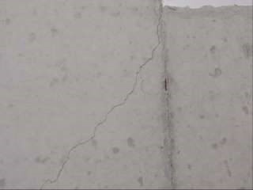
10)

Cracks found in walls in several areas walls by windows and floor (this are likely caused by settlement). Recommend monitoring these area for widening or
lengthening of cracks. If cracks continue to grow recommend a qualified technician evaluate and make necessary corrections.

Photo 10
-
1

Photo 10
-
2

Photo 10
-
3

Photo 10
-
4

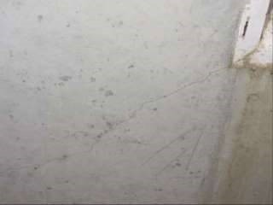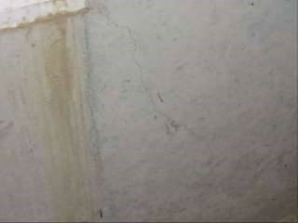

Photo 10-5 Photo 10-6
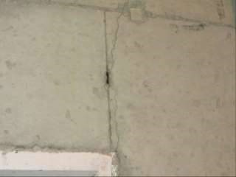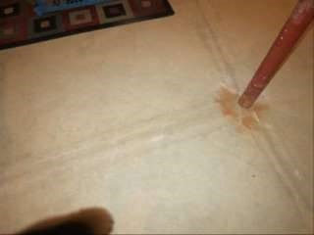

Photo 10-7 Photo 10-8
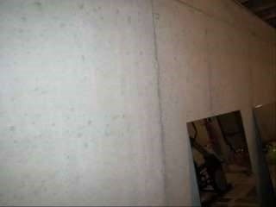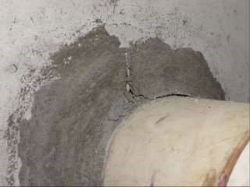

Photo 10-9 Photo 10-10

Roof
Limitations: The following items or areas are not included in this inspection: areas that could not be traversed or viewed clearly due to lack of access; solar roofing components. Any comments made regarding these items are made as a courtesy only. Note that the inspector does not provide an estimate of remaining life on the roof surface material, nor guarantee that leaks have not occurred in the roof surface, skylights or roof penetrations in the past. Regarding roof leaks, only active leaks, visible evidence of possible sources of leaks, and evidence of past leaks observed during the inspection are reported on as part of this inspection. The inspector does not guarantee or warrant that leaks will not occur in the future. Complete access to all roof and attic spaces during all seasons and during prolonged periods of all types of weather conditions (e.g. high wind and rain, melting snow) would be needed to do so. Regarding the roof drainage system, unless the inspection was conducted during and after prolonged periods of heavy rain, the inspector was unable to determine if gutters, downspouts and extensions performed adequately or were leak-free. Roof inspection method: Traversed
Condition of roof surface material: Appeared serviceable
Roof surface material: Asphalt or fiberglass composition shingles Roof type: Gable
Apparent number of layers of roof surface material: One
Condition of exposed flashings: Appeared serviceable
Condition of gutters, downspouts and extensions: Appeared serviceable
11) Extensions such as splash blocks or drain pipes for one or more downspouts were missing. Water can accumulate around the building foundation or inside crawl spaces or basements as a result. Recommend that a qualified person install, replace or repair extensions as necessary so rainwater drains away from the structure.
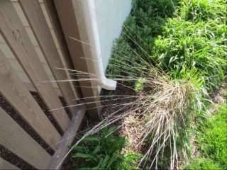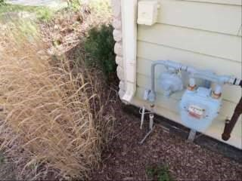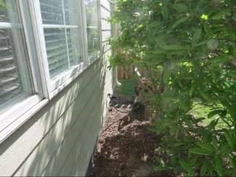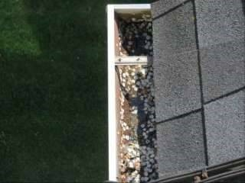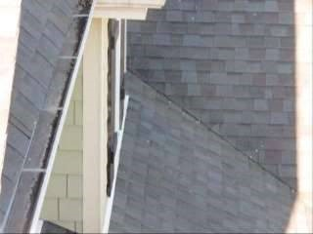

12)
Debris has accumulated in one or several gutters. Gutters can overflow and cause water to come in contact with the building exterior, or water can accumulate
around the foundation. This is a conducive condition for wood
-
destroying organisms. Recommend cleaning gutters and downspouts now and as necessary in the future.

Photo 11
-
1

Photo 11
-
2

Photo 11
-
3

Photo 12
-
1

Photo 12
-
2

Attic and Roof Structure
Limitations: The following items or areas are not included in this inspection: areas that could not be traversed or viewed clearly due to lack of access; areas and components obscured by insulation. Any comments made regarding these items are made as a courtesy only. The inspector does not determine the adequacy of the attic
ventilation system. Complete access to all roof and attic spaces during all seasons and during prolonged periods of all types of weather conditions (e.g. high/low temperatures, high/low humidity, high wind and rain, melting snow) would be needed to do so. The inspector is not a licensed engineer and does not determine the adequacy of roof structure components such as trusses, rafters or ceiling beams, or their spacing or sizing.
Attic inspection method: Viewed from hatch(es)
Condition of roof structure: Appeared serviceable
Roof structure type: Rafters
Ceiling structure: Ceiling joists, Ceiling beams
Condition of insulation in attic (ceiling, skylight chase, etc.): Appeared serviceable
Ceiling insulation material: Cellulose loose fill
Approximate attic insulation R value (may vary in areas): R-38
Condition of roof ventilation: Appeared serviceable
Roof ventilation type: Box vents (roof jacks), Enclosed soffit vents
13) Both attic access hatches or doors were not insulated. Weatherstripping was also missing. Recommend installing weatherstripping and insulation per current standards at hatches or doors for better energy efficiency. For more information, visit:
http://www.reporthost.com/?ATTACC
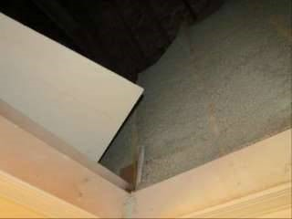
Photo 13-1

Garage or Carport
Limitations: The inspector does not determine the adequacy of firewall ratings. Requirements for ventilation in garages vary between municipalities.
Type: Attached
Condition of door between garage and house: Appeared serviceable
Type of door between garage and house: Metal
Condition of garage vehicle door(s): Appeared serviceable
Type of garage vehicle door: Sectional
Number of vehicle doors: 1
Condition of automatic opener(s): Appeared serviceable
Mechanical auto-reverse operable (reverses when meeting reasonable resistance during closing): Yes
Condition of garage floor: Appeared serviceable
Condition of garage interior: Appeared serviceable
Garage ventilation: Adequate

Electric
Limitations: The following items are not included in this inspection: generator systems, transfer switches, surge suppressors, inaccessible or concealed wiring; underground utilities and systems; low-voltage lighting or lighting on timers or sensors. Any comments made regarding these items are as a courtesy only. Note that the inspector does not determine the adequacy of grounding or bonding, if this system has an adequate capacity for the client's specific or anticipated needs, or if this system has any reserve capacity for additions or expansion. The inspector does not operate circuit breakers as part of the inspection, and does not install or change light bulbs. The inspector does not evaluate every wall switch or receptacle, but instead tests a representative number of them per various standards of practice. When furnishings, stored items or child-protective caps are present some receptacles are usually inaccessible and are not tested; these are excluded from this inspection. Receptacles that are not of standard 110 volt configuration, including 240-volt dryer receptacles, are not tested and are excluded. The functionality of, power source for and placement of smoke and carbon monoxide alarms is not determined as part of this inspection. Upon taking occupancy, proper operating and placement of smoke and carbon monoxide alarms should be verified and batteries should be changed. These devices have a limited lifespan and should be replaced every 10 years. The inspector attempts to locate and evaluate all main and sub-panels. However, panels are often concealed. If panels are found after the inspection, a qualified electrician should evaluate and repair if necessary. The inspector attempts to determine the overall electrical service size, but such estimates are not guaranteed because the overall capacity may be diminished by lesser-rated components in the system. Any repairs recommended should be made by a licensed electrician. Electric service condition: Appeared serviceable
Primary service type: Underground
Service voltage (volts): 120-240
Estimated service amperage: 200
Primary service overload protection type: Circuit breakers
Service entrance conductor material: Stranded copper
Main disconnect rating (amps): 200
Condition of main service panel: Appeared serviceable
Condition of sub-panel(s): Appeared serviceable
Location of main service panel #A: Basement
Location of sub-panel #C: Basement
Condition of branch circuit wiring: Serviceable
Branch circuit wiring type: Copper
- Carbon monoxide alarm were missing in basement. This is a potential safety hazard. Some states and/or municipalities require CO alarms to be installed in the vicinity of each sleeping area, on each level and in accordance with the manufacturer's recommendations. Recommend installing additional carbon monoxide alarms per these standards. For more information, visit: http://www.reporthost.com/?COALRM
- Some breakers in main service panel appear to be loose. I noticed when removing the cover of the panel, lights were flashing on and off. Recommend a qualified electrician evaluate and a make necessary corrections.
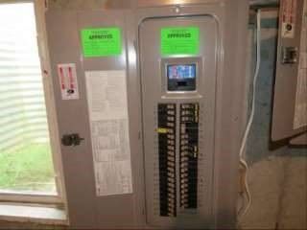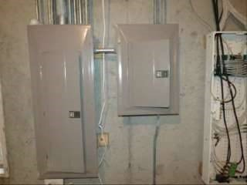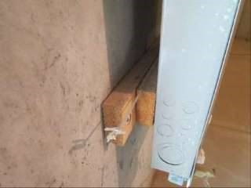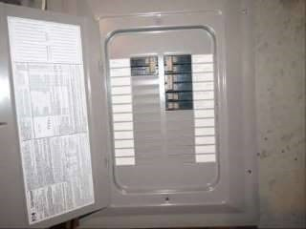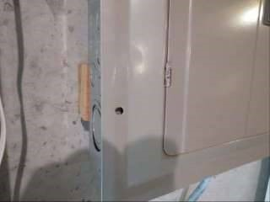
16)

Main panel not fully secured to wall. I noticed some movement of the panel when removing the cover. Recommend a qualified electrician evaluate and make
necessary corrections.

17)
Sub panel cover missing a screw.

Photo 15
-
1

Photo 16
-
1

Photo 16
-
2

Photo 17
-
1

Photo 17
-
2

Plumbing / Fuel Systems
Limitations: The following items are not included in this inspection: private/shared wells and related equipment; private sewage disposal systems; hot tubs or spas; main, side and lateral sewer lines; gray water systems; pressure boosting systems; trap primers; incinerating or composting toilets; fire suppression systems; water softeners, conditioners or filtering systems; plumbing components concealed within the foundation or building structure, or in inaccessible areas such as below tubs; underground utilities and systems; overflow drains for tubs and sinks; backflow prevention devices. Any comments made regarding these items are as a courtesy only. Note that the inspector does not operate water supply or shut-off valves due to the possibility of valves leaking or breaking when operated. The inspector does not test for lead in the water supply, the water pipes or solder, does not determine if plumbing and fuel lines are adequately sized, and does not determine the existence or condition of underground or above-ground fuel tanks.
Condition of service and main line: Appeared serviceable Water service: Public
Location of main water shut-off: Basement
Condition of supply lines: Appeared serviceable
Supply pipe material: Copper
Condition of drain pipes: Appeared serviceable
Drain pipe material: Plastic
Condition of waste lines: Appeared serviceable
Waste pipe material: Plastic
Vent pipe condition: Appeared serviceable
Vent pipe material: Plastic
Sump pump installed: Yes
Condition of sump pump: Not determined (inaccessible or obscured)
Sewage ejector pump installed: Yes
Condition of sewage ejector pump: Not determined (inaccessible or obscured)
Condition of fuel system: Appeared serviceable Visible fuel storage systems: Below ground
Location of main fuel shut-off valve: At gas meter

Water Heater

Limitations: Evaluation of and determining the adequacy or completeness of the following items are not included in this inspection: water recirculation pumps; solar water heating systems; Energy Smart or energy saver controls; catch pan drains. Any comments made regarding these items are as a courtesy only. Note that the inspector does not provide an estimate of remaining life on water heaters, does not determine if water heaters are appropriately sized, or perform any evaluations that require a pilot light to be lit or a shut-off valve to be operated.
Condition of water heater: Appeared serviceable
Type: Tank
Energy source: Natural gas
Estimated age: 2010
Capacity (in gallons): 50
Temperature-pressure relief valve installed: Yes
Location of water heater: Basement
Condition of burners: Appeared serviceable
Condition of venting system: Appeared serviceable

Heating, Ventilation and Air Condition (HVAC)
Limitations: The following items are not included in this inspection: humidifiers, dehumidifiers, electronic air filters; solar, coal or wood-fired heat systems; thermostat or temperature control accuracy and timed functions; heating components concealed within the building structure or in inaccessible areas; underground utilities and systems; safety devices and controls (due to automatic operation). Any comments made regarding these items are as a courtesy only. Note that the inspector does not provide an estimate of remaining life on heating or cooling system components, does not determine if heating or cooling systems are appropriately sized, does not test coolant pressure, or perform any evaluations that require a pilot light to be lit, a shut-off valve to be operated, a circuit breaker to be turned "on" or a serviceman's or oil emergency switch to be operated. It is beyond the scope of this inspection to determine if furnace heat exchangers are intact and free of leaks. Condensation pans and drain lines may clog or leak at any time and should be monitored while in operation in the future. Where buildings contain furnishings or stored items, the inspector may not be able to verify that a heat source is present in all "liveable" rooms (e.g. bedrooms, kitchens and living/dining rooms).
General heating system type(s): Forced air, Furnace
General heating distribution type(s): Ducts and registers
Condition of forced air heating/(cooling) system: Appeared serviceable
Forced air heating system fuel type: Natural gas
Location of forced air furnace: Basement, and 2nd floor
Condition of furnace filters: Appeared serviceable
Location for forced air filter(s): At end of air handler
Condition of forced air ducts and registers: Appeared serviceable
Condition of burners: Appeared serviceable
Type of combustion air supply: Vent(s) to exterior
Condition of cooling system and/or heat pump: Appeared serviceable
Cooling system and/or heat pump fuel type: Natural gas
Type: Split system
Condition of controls: Appeared serviceable
18) I was unable to determine the last service date on both furnaces and A/C. Ask the property owner when it was last serviced. If unable to determine the last service date, or if this system was serviced more than 1 year ago, recommend that a qualified HVAC contractor inspect, clean, and service this system, and make repairs if necessary. For safety reasons, and because this system is fueled by gas, this servicing should be performed annually in the future. Any needed repairs noted in this report should be brought to the attention of the HVAC contractor when it's serviced. For more information visit:
http://www.reporthost.com/?ANFURINSP
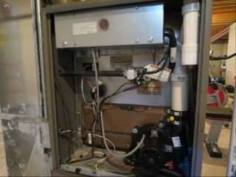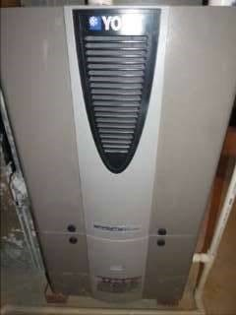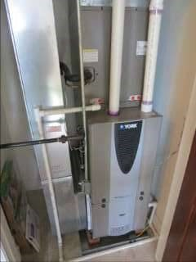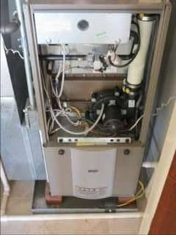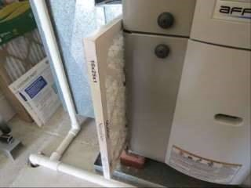

19)
Recommend replacing HVAC filters upon taking occupancy. Recommend checking filters monthly in the future and replacing or washing them as necessary. How
frequently they need replacing or washing depends on the type and quality of the filter, how the system is configured (e.g. always on vs. "Auto"), and on environmental
factors (e.g. pets, smoking, frequency of house cleaning, number of occupants, the season).

Photo 18
-
1

Photo 18
-
2

Photo 18
-
3

Photo 18
-
4

Photo 19
-
1

Fireplaces, Stoves, Chimneys and Flues
Limitations: The following items are not included in this inspection: coal stoves, gas logs, chimney flues (except where visible). Any comments made regarding these items are as a courtesy only. Note that the inspector does not determine the adequacy of drafting or sizing in fireplace and stove flues, and also does not determine if prefabricated or zero-clearance fireplaces are installed in accordance with the manufacturer's specifications. The inspector does not perform any evaluations that require a pilot light to be lit, and does not light fires. The inspector provides a basic visual examination of a chimney and any associated wood burning device. The National Fire Protection Association has stated that an in-depth Level 2 chimney inspection should be part of every sale or transfer of property with a wood-burning device. Such an inspection may reveal defects that are not apparent to the home inspector who is a generalist.
Condition of gas-fired fireplaces or stoves: Appeared serviceable
Gas fireplace or stove type: Metal pre-fab fireplace
Condition of chimneys and flues: Appeared serviceable
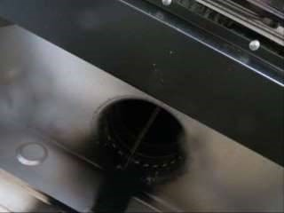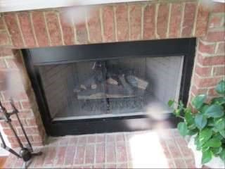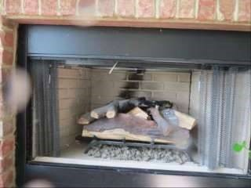
Wood
-
burning chimney type:

Gas
-
fired flue type:
B
-
vent

20)

Recommend that the client review all available documentation for gas
-
fired fireplaces. Depending on how they are operated (for routine heating versus
ambiance), such appliances may need servicing annually or every few years. Consult with the property owner and/or a qualified specialist to determine if service is needed
now.

Photo 20
-
1

Photo 20
-
2

Photo 20
-
3

Kitchen
Limitations: The following items are not included in this inspection: household appliances such as stoves, ovens, cook tops, ranges, warming ovens, griddles, broilers, dishwashers, trash compactors, refrigerators, freezers, ice makers, hot water dispensers and water filters; appliance timers, clocks, cook functions, self and/or continuous cleaning operations, thermostat or temperature control accuracy, and lights. Any comments made regarding these items are as a courtesy only. Note that the inspector does not provide an estimate of the remaining life of appliances, and does not determine the adequacy of operation of appliances. The inspector does not note appliance manufacturers, models or serial numbers and does not determine if appliances are subject to recalls. Areas and components behind and obscured by appliances are inaccessible and excluded from this inspection. Condition of counters: Appeared serviceable
Condition of cabinets: Appeared serviceable
Condition of sinks and related plumbing: Appeared serviceable
Condition of under-sink food disposal: Appeared serviceable
Condition of dishwasher: Appeared serviceable
Condition of range, cooktop or oven: Appeared serviceable
Range, cooktop or oven type: Natural gas
Type of ventilation: Hood or built into microwave over range or cooktop
Condition of refrigerator: Appeared serviceable
Condition of built-in microwave oven: Appeared serviceable
21)

Knob missing from vent hood fan.

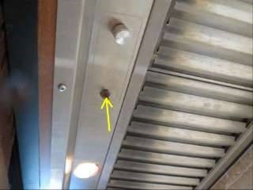
Photo 21-1

Bathrooms, Laundry and Sinks
Limitations: The following items are not included in this inspection: overflow drains for tubs and sinks; heated towel racks, saunas, steam generators, clothes washers, clothes dryers. Any comments made regarding these items are as a courtesy only. Note that the inspector does not determine the adequacy of washing machine drain lines, washing machine catch pan drain lines, or clothes dryer exhaust ducts. The inspector does not operate water supply or shut-off valves for sinks, toilets, bidets, clothes washers, etc. due to the possibility of valves leaking or breaking when operated. The inspector does not determine if shower pans or tub and shower enclosures are water tight, or determine the completeness or operability of any gas piping to laundry appliances.
Location #A: Half bath, first floor
Location #B: Full bath, Master bath, first floor
Location #C: Full bath, second floor
Condition of counters: Appeared serviceable
Condition of cabinets: Appeared serviceable
Condition of flooring: Appeared serviceable
Condition of sinks and related plumbing: Appeared serviceable
Condition of toilets: Appeared serviceable
Condition of bathtubs and related plumbing: Appeared serviceable
Condition of shower(s) and related plumbing: Appeared serviceable
Condition of ventilation systems: Appeared serviceable
Bathroom and laundry ventilation type: Spot exhaust fans

Interior, Doors and Windows
Limitations: The following items are not included in this inspection: security, intercom and sound systems; communications wiring; central vacuum systems; elevators and stair lifts; cosmetic deficiencies such as nail-pops, scuff marks, dents, dings, blemishes or issues due to normal wear and tear in wall, floor and ceiling surfaces and coverings, or in equipment; deficiencies relating to interior decorating; low voltage and gas lighting systems. Any comments made regarding these items are as a courtesy only. Note that the inspector does not evaluate any areas or items which require moving stored items, furnishings, debris, equipment, floor coverings, insulation or similar materials. The inspector does not test for asbestos, lead, radon, mold, hazardous waste, urea formaldehyde urethane, or any other toxic substance. Some items such as window, drawer, cabinet door or closet door operability are tested on a sampled basis. The client should be aware that paint may obscure wall and ceiling defects, floor coverings may obscure floor defects, and furnishings may obscure wall, floor and floor covering defects. If furnishings were present during the inspection, recommend a full evaluation of walls, floors and ceilings that were previously obscured when possible. Determining the cause and/or source of odors is not within the scope of this inspection. Condition of exterior entry doors: Appeared serviceable
Exterior door material: Fiberglass or vinyl
Condition of interior doors: Appeared serviceable
Condition of windows and skylights: Appeared serviceable
Type(s) of windows: Vinyl, Wood, Single-pane, Casement
Condition of walls and ceilings: Appeared serviceable
Wall type or covering: Drywall
Condition of flooring: Appeared serviceable
Condition of concrete slab floor(s): Appeared serviceable Flooring type or covering: Carpet, Wood or wood products, Tile Condition of stairs, handrails and guardrails:
22) Crank handles at kitchen, livingroom and master bedroom windows were loose and/or broken. Recommend that a qualified person replace handles or make repairs as necessary.
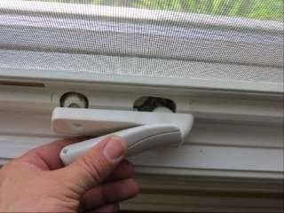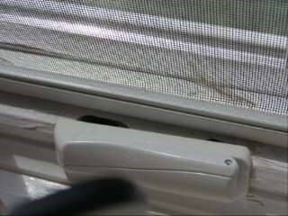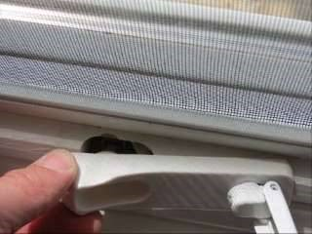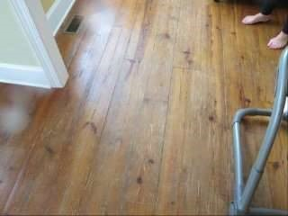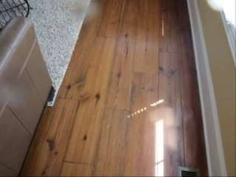 Minor cracks were found in walls and ceilings in master bedroom and master bathroom. Cracks and nail pops are common, are often caused by lumber shrinkage or minor settlement, and can be more or less noticeable depending on changes in humidity. They did not appear to be a structural concern, but the client may wish to repair these for aesthetic reasons. For recurring cracks, consider using an elastic crack covering product:

23)
Wood flooring in some areas was
worn. Recommend that a qualified contractor refinish wood flooring as necessary.

24)

Photo 22
-
1

Photo 22
-
2

Photo 22
-
3

Photo 23
-
1

Photo 23
-
2

Photo 23
-
3

http://www.reporthost.com/?ECC
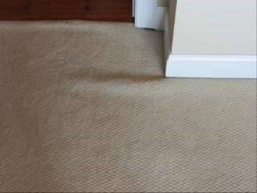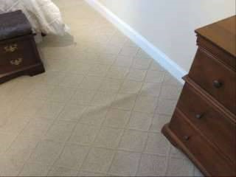
25)

Carpeting in bedroom 1 and 4 upstairs was loose. Recommend that a qualified contractor repair as necessary. For example, by stretching or replacing carpeting.

Photo 24
-
1

Photo 24
-
2

Photo 24
-
3

Photo 24
-
4

Photo 24
-
5

Photo 25
-
1

Photo 25
-
2

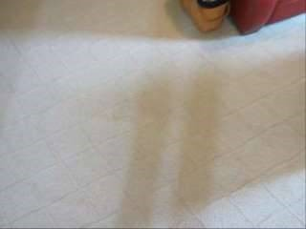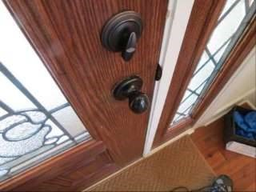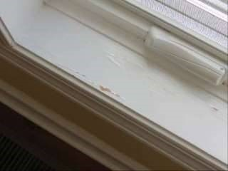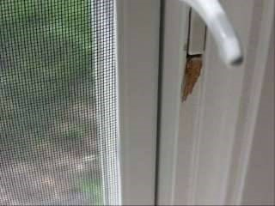
26)

Front door knob loose. Recommend a qualified person repair as necessary.

27)

Two areas of chipping paint on window trim.

Photo 25
-
3

Photo 26
-
1

Photo 27
-
1

Photo 27
-
2

Wood Destroying Organism Findings
Limitations: This report only includes findings from accessible and visible areas on the day of the inspection. In addition to the inaccessible areas documented in this report, examples of other inaccessible areas include: sub areas less than 18 inches in height; attic areas less than 5 feet in height, areas blocked by ducts, pipes or insulation; areas where locks or permanently attached covers prevent access; areas where insulation would be damaged if traversed; areas obscured by vegetation. All inaccessible areas are subject to infestation or damage from wood-destroying organisms. The inspector does not move furnishings, stored items, debris, floor or wall coverings, insulation, or other materials as part of the inspection, nor perform destructive testing. Wood-destroying organisms may infest, re-infest or become active at any time. No warranty is provided as part of this inspection. Visible evidence of active wood-destroying insects: No
Visible evidence of active wood decay fungi: No
Visible evidence of past wood-destroying insects: No
Visible evidence of past wood decay fungi: No
Visible evidence of damage by wood-destroying insects: No
Visible evidence of damage by wood decay fungi: No
Visible evidence of conditions conducive to wood-destroying organisms: No

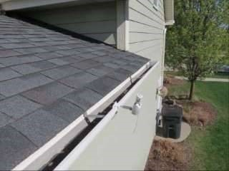

Photo X-1 Photo X-2
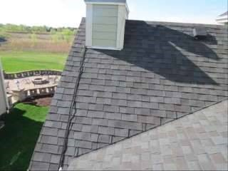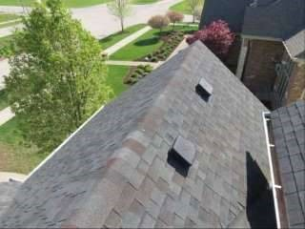

Photo X-3 Photo X-4
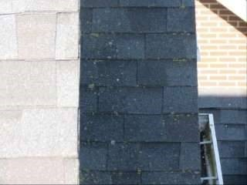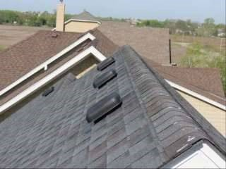

Photo X-5 Photo X-6
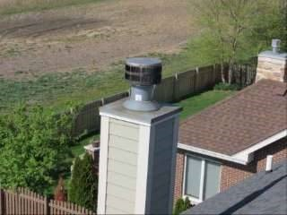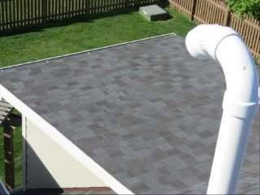
-7 -8
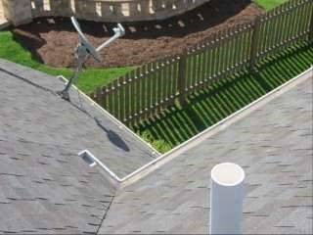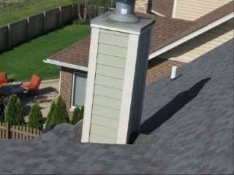

Photo X-9 Photo X-10
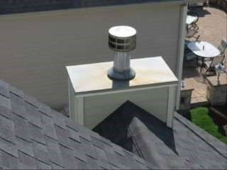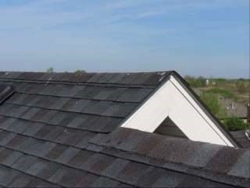

Photo X-11 Photo X-12
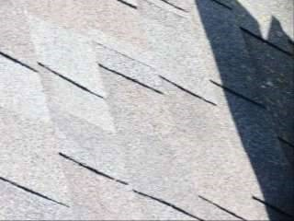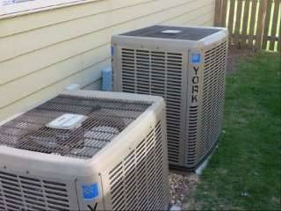

Photo X-13 Photo X-14
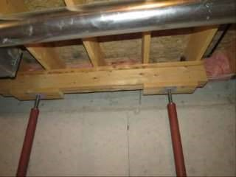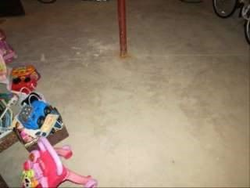
-15 -16
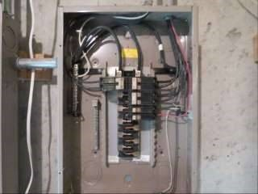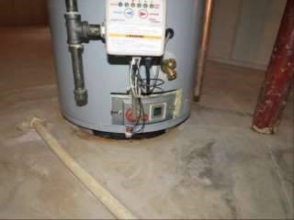

Photo X-17 Photo X-18
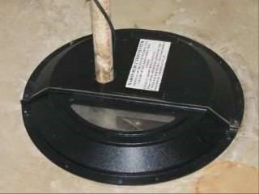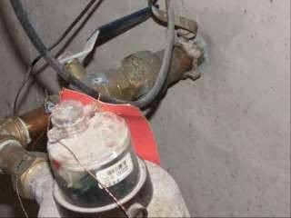

Photo X-19 Photo X-20
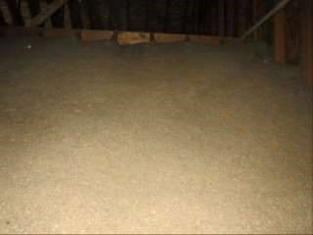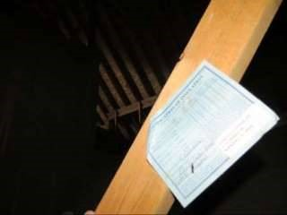

Photo X-21 Photo X-22
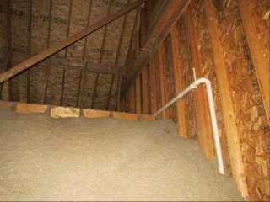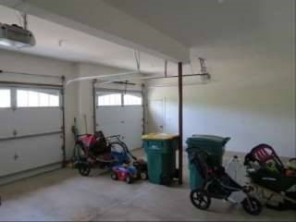
-23 -24

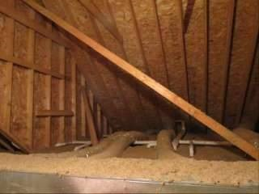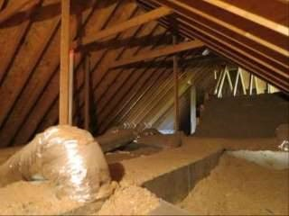

Photo X-25 Photo X-26
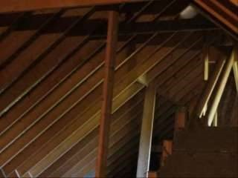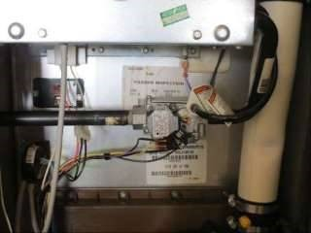

Photo X-27 Photo X-28
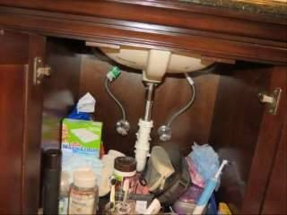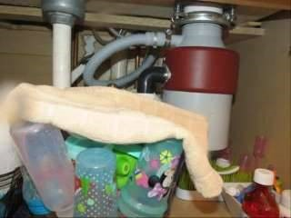

Photo X-29 Photo X-30

Inspector: Tom Spielman
LIC# 450010852

